SBT-DF204 COMPUTER FORENSICS CASE STUDY 1
Investigating Harassment Email Traffic With Wireshark

Student information | Details
Full name | Sumayyah Badmus
Registration number | 2025/FWSD/2511425
Course code | SBT-DF204
Case title | Investigating Harassment Email Traffic With Wireshark

Executive Conclusion

I examined the supplied nitroba.pcap network capture using Wireshark and reviewed the HTTP traffic connected with the reported harassment message. The investigation identified client IP address 192.168.15.4 communicating with 69.25.94.22, which hosted www.willselfdestruct.com.
The most important evidence was frame 83601, where the client sent an HTTP POST request to
/secure/submit. The submitted information included the recipient lilytuckrige@yahoo.com, the subject “you can't find us”, and the message “and you can't hide from us. Stop teaching. Start running.”
The same client traffic was associated with MAC address 00:17:f2:e2:c0:ce and the account identifier jcoachj@gmail.com. The supplied scenario evidence associates this account with Johnny Coach, who is listed in Chemistry 109.
Based on the packet evidence, there is a strong connection between the captured network activity, the account, and the Chemistry 109 roster entry. However, I would not treat the evidence as absolute proof that Johnny Coach personally operated the computer at the time. The capture identifies network and account activity, but a shared network environment means that IP and MAC addresses alone cannot establish the identity of the individual who physically used the computer.

Evidence Acquisition and Integrity

The evidence was examined and investigate was the supplied nitroba.pcap packet capture. The recorded file details were:
Evidence item | Result
Filename | nitroba.pcap
File size | 817,689 bytes
Acquisition date | 2026-10-02
SHA-256  Original | 2b77a9eaefc1d6af163d1ba793c96dbccacb04e6befdf1a0b01f8c67553ec2fb nitroba.pcap
SHA-256  working copy | 2b77a9eaefc1d6af163d1ba793c96dbccacb04e6befdf1a0b01f8c67553ec2fb working/nitroba_working.pcap
Checksum  comparison | Original and working-copy hashes match

The original evidence was preserved by creating a separate working copy before carrying out the Wireshark examination. This allowed the analysis to be performed on the working copy while keeping the original evidence unchanged. The file was saved in SBTDF204-CaseStudy1/reports/acquisition.txt

Evidence reference: E01
Related appendix: Appendix A

Method
I opened the working packet capture in Wireshark and started by reviewing the HTTP traffic contained in the capture.
I used HTTP filters to locate requests associated with the willselfdestruct.com service. I then examined the relevant packets individually and followed the TCP conversation to see the
complete exchange between the client and the web server. The main stages of the examination were:
  - Open working/nitroba_working.pcap in Wireshark.
  - Review HTTP GET and POST requests.
  - Identify traffic involving www.willselfdestruct.com.
  - Identify the client IP address and destination server IP address.
  - Examine the request to /secure/submit.
  - Follow the TCP stream containing the request.
  - Examine the submitted form information.
  - Identify the client MAC address associated with the traffic.
  - Search the capture for account identifiers and cookies.
  - Compare the account information with the supplied Chemistry 109 roster.
  - Arrange the relevant packets in chronological order.
  - Record the findings in the evidence log and preserve screenshots of the important Wireshark views.
The main packet used to establish the harassment submission was frame 83601, which was part of TCP stream 447.

Findings
Question 1 — What file did I acquire, and how did I preserve its integrity?
The file examined was nitroba.pcap. Its recorded size was 817,689 bytes.
The investigation record gives the acquisition date as 2026-10-02. A working copy named: working/nitroba_working.pcap was used for the Wireshark examination.
The recorded SHA-256 values were documented in SBTDF204-
CaseStudy1/reports/acquisition.txt with the evidence so that the capture could be identified and checked for integrity.
Evidence: E01
File: nitroba.pcap
Working copy: working/nitroba_working.pcap

Question 2 — Which client system contacted the web service?
The client system identified in the relevant traffic was:
Client IP: 192.168.15.4
The destination server was:
Destination IP: 69.25.94.22 The HTTP Host field identified:
www.willselfdestruct.com The relevant request used:
/secure/submit
Frame 82936 showed the client communicating with the service before the final POST request.
The more important packet was frame 83601, where the client sent the POST request containing the submitted message.
Frame: 83601
Time: 2008-07-22 02:04:24.311700
Source: 192.168.15.4
Destination: 69.25.94.22

Protocol: HTTP
Request: POST /secure/submit
Evidence: E02

Question 3 — What evidence links the client to the harassment message?
The strongest evidence was frame 83601. The packet contains an HTTP POST request:
POST /secure/submit HTTP/1.1 The request was sent to:
www.willselfdestruct.com
The submitted information recorded in the packet was:
Recipient: lilytuckrige@yahoo.com Subject: you can't find us Message:
and you can't hide from us. Stop teaching. Start running. The packet was part of TCP stream 447.
This is important because the packet does not simply show that the client visited the website. It shows the client submitting the information associated with the reported harassment message.
Frame: 83601
Timestamp: 2008-07-22 02:04:24.311700

TCP stream: 447
Source: 192.168.15.4
Destination: 69.25.94.22 Wireshark filters used: frame.number == 83601 and
tcp.stream == 447

Evidence: E02 and E03
Screenshots: Appendix B and Appendix C

Question 4 — Which device made the relevant request?
The client MAC address associated with the traffic was:
00:17:f2:e2:c0:ce
The network relationship was:

Item Value
Client IP 192.168.15.4
Client MAC 00:17:f2:e2:c0:ce Service IP 69.25.94.22
The MAC address was also observed in frame 77711.
The packet was examined using the filter:
eth.addr == 00:17:f2:e2:c0:ce && http.cookie contains "@" Frame 77711 was recorded at:
2008-07-22 02:01:45.361069
This provides additional evidence connecting the relevant traffic to the same network interface.
I would not treat the MAC address as proof of a particular person. It identifies the network interface involved in the captured traffic, not necessarily the individual who was using the device.
Evidence: E01 and E04

Question 5 — Who is associated with the device?
The capture contained the account identifier:
jcoachj@gmail.com
Frame 77711 contained account information associated with the client MAC address.

A second identity-related packet was frame 79093, recorded at:
2008-07-22 02:04:01.359793
The filter used was:
eth.addr == 00:17:f2:e2:c0:ce && frame contains "jcoachj@gmail.com" The investigation material associates this account with Johnny Coach.
This gives an account-level connection between the captured device traffic and the named person in the supplied scenario evidence.
Evidence: E04 and E05

Question 6 — Is that person on the Chemistry 109 roster?
Yes.
The supplied scenario evidence identifies:
Student: Johnny Coach
Course: Chemistry 109
Account: jcoachj@gmail.com
The account identifier found in the network traffic corresponds to the name Johnny Coach in the supplied Chemistry 109 roster information.
Therefore, the packet evidence can be connected to an account that is associated with a student listed in Chemistry 109.
This is an important part of the investigation, but it should not be interpreted as proof that the student personally typed the message. The evidence establishes an association between the
account, network device, and roster information.
Evidence: E06
Roster: Chemistry 109, Slide 14

Question 7 — When did the relevant activity occur?
The relevant activity occurred on 22 July 2008. Important packet times include:
Time | Frame | Activity
01:57:23.533987 | 72122 | HTTP GET to Microsoft
02:01:45.361069 | 77711 | HTTP POST containing account information
02:04:01.359793 | 79093 | Account identity evidence
02:03:43.825871 | 82936 | HTTP GET to /secure/submit
02:03:44.210976 | 82998 | TCP/HTTP data associated with the service
02:04:24.311700 | 83601 | HTTP POST containing the harassment message
The most significant time is:
2008-07-22 02:04:24.311700
because this is the timestamp of frame 83601 containing the submitted message.
Evidence: Timeline and E02/E04/E05

Question 8 — What conclusion can be defended?
The packet capture provides strong evidence that the client at 192.168.15.4, using MAC address 00:17:f2:e2:c0:ce, communicated with www.willselfdestruct.com and submitted the reported harassment message.
The traffic also contains account information identifying jcoachj@gmail.com. The supplied
scenario information connects that account with Johnny Coach, who is listed in Chemistry 109. Therefore, the evidence supports an association between:
Client → MAC address → account → roster entry → harassment submission
However, the evidence does not independently prove that Johnny Coach was physically operating the computer when the message was submitted. The network and account
information should therefore be treated as an attribution link rather than absolute proof of the person's physical presence or actions.

Timeline

Time | Frame | Source | Destination | Activity
2008-07-22  02:00:45.360749 | 77711 | 192.168.15.4 | 74.125.19.104 | HTTP POST to /calendar/load associated with Google Calendar
2008-07-22  02:01:05.113795 | 79093 | 192.168.15.4 | 74.125.19.17 | TCP segment carrying HTTP POST data; reassembled HTTP request begins with POST  /mail/cha...
2008-07-22  02:03:43.825871 | 82936 | 192.168.15.4 | 69.25.94.22 | HTTP GET /secure/submit
2008-07-22  02:03:44.210976 | 82998 | 69.25.94.22 | 192.168.15.4 | TCP PSH, ACK carrying HTTP data / reassembled TCP data
2008-07-22  02:04:24.311700 | 83601 | 192.168.15.4 | 69.25.94.22 | HTTP POST to /secure/submit; submitted form data including subject and message
2008-07-22  01:57:23.533987 | 72122 | 192.168.15.4 | 207.46.19.190 | HTTP GET  /isapi/redir.dll?prd=ie&pver=6&ar=msnhome

The most important event in the timeline is frame 83601, because it contains the actual submitted recipient, subject and message.

Attribution Assessment Observed facts
The packet capture shows that:
- 192.168.15.4 communicated with 69.25.94.22.
- The destination host was www.willselfdestruct.com.
- The client used MAC address 00:17:f2:e2:c0:ce.
- Frame 83601 contained an HTTP POST to /secure/submit.
- The POST contained the recipient lilytuckrige@yahoo.com.
- The subject was you can't find us.
- The message was and you can't hide from us. Stop teaching. Start running.

- The capture contained the account identifier jcoachj@gmail.com.
- The supplied scenario information associates this account with Johnny Coach.

- Johnny Coach is listed in Chemistry 109.

Inferences

The evidence supports the inference that the computer/network interface associated with 192.168.15.4 and 00:17:f2:e2:c0:ce was used to submit the harassment message.
The account evidence also supports an association between the captured traffic and Johnny Coach.

Limitations

The IP address and MAC address do not by themselves prove who was physically using the computer.
The presence of an account identifier in captured traffic also does not necessarily prove that the named account holder personally generated the message. Another person could potentially have used the computer or account.
The shared-network environment is therefore an important limitation when making an attribution.

Confidence
I would describe the network-to-account association as high confidence based on the supplied packet evidence, while the identification of the individual who physically sent the message should be treated with lower confidence because the capture alone cannot establish who was operating the device at that exact time.
My conclusion is therefore that the evidence strongly associates the harassment submission with the identified client, MAC address and account associated with Johnny Coach, but it should not be presented as absolute proof of personal authorship.

Appendices
Appendix 001 — Evidence file map

Purpose | Exact file/path inside supplied ZIP
Acquisition and hash record | SBTDF204-CaseStudy1/reports/acquisition.txt
Relevant POST notes | SBTDF204-CaseStudy1/reports/post_analysis.txt
Timeline | SBTDF204-CaseStudy1/reports/timeline.txt
Original evidence capture | SBTDF204-CaseStudy1/evidence/nitroba.pcap
Working capture | SBTDF204-CaseStudy1/working/nitroba_working.pcap
Scenario slides / Chemistry 109 list | SBTDF204-  CaseStudy1/evidence/scenario_material/nitroba_slides.pdf
Time display screenshot | SBTDF204-CaseStudy1/screenshots/01_time_display.png
Relevant HTTP POST screenshot | SBTDF204-CaseStudy1/screenshots/02_relevant_http_post .png
TCP stream screenshot | SBTDF204-CaseStudy1/screenshots/03_tcp_stream.png
Cookie/account screenshot | SBTDF204-CaseStudy1/screenshots/04_cookie_identity.png
Identity evidence screenshot | SBTDF204-CaseStudy1/screenshots/05_identity_evidence.png

Appendix A Screenshot — Evidence Integrity
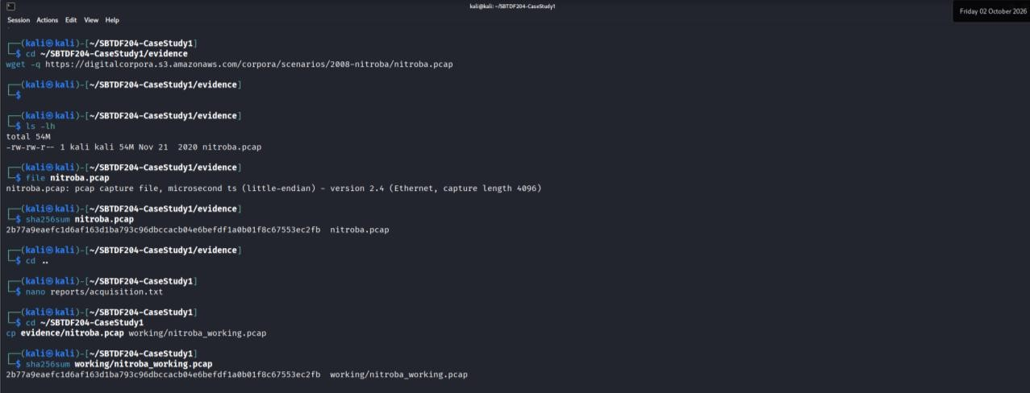
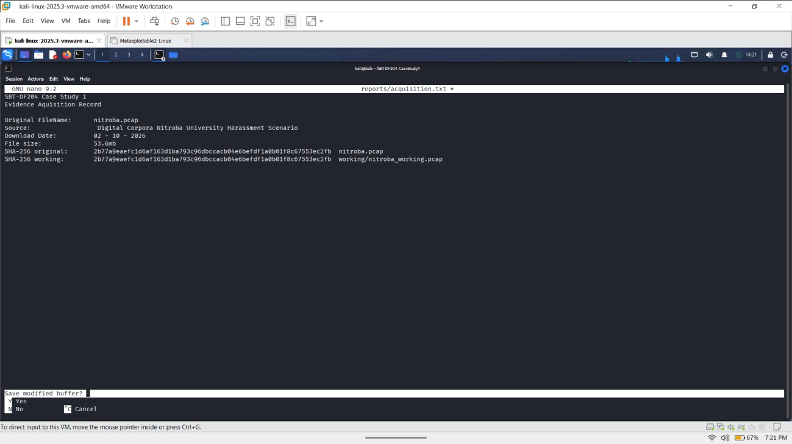
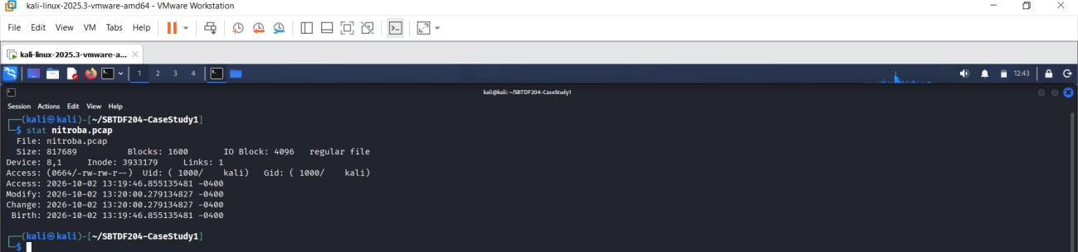

Evidence ID: E01

Appendix B — Relevant HTTP POST
The Wireshark screenshot for frame 83601.
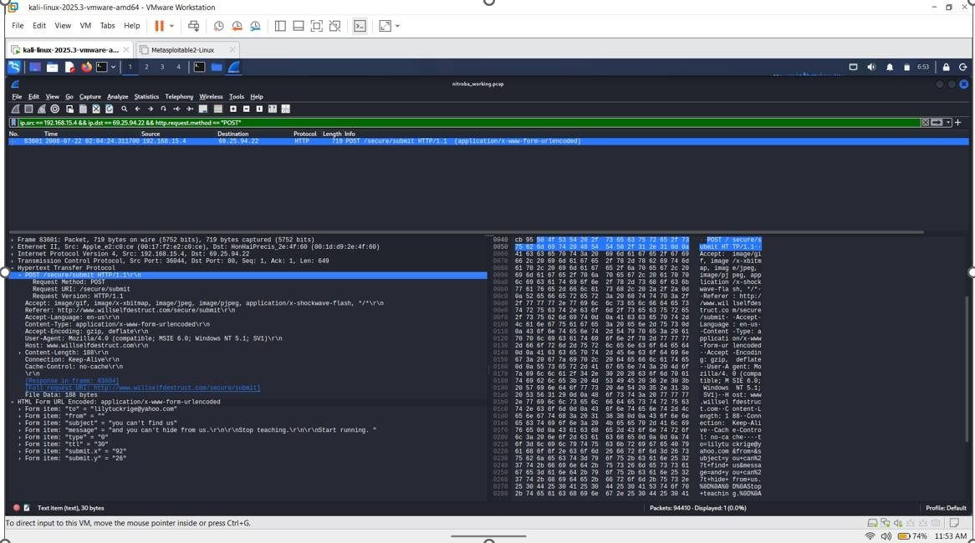

Evidence ID: E02

Appendix C — TCP Stream
Include the Follow TCP Stream screenshot showing TCP stream 447.

Field | Value
Frame number | 83601
Timestamp | 2008-07-22 02:04:24.311700
Source IP | 192.168.15.4
Destination IP | 69.25.94.22
Source port | 36044
Destination port | 80
HTTP request | POST /secure/submit HTTP/1.1
Request URI | /secure/submit
Recipient | lilytuckrige@yahoo.com
Subject | you can't find us

Message | and you can't hide from us. Stop teaching.  Start running.
TCP stream | 447
Host | www.willselfdestruct.com
User-Agent | Mozilla/4.0 (compatible; MSIE 6.0; Windows NT 5.1; SV1)

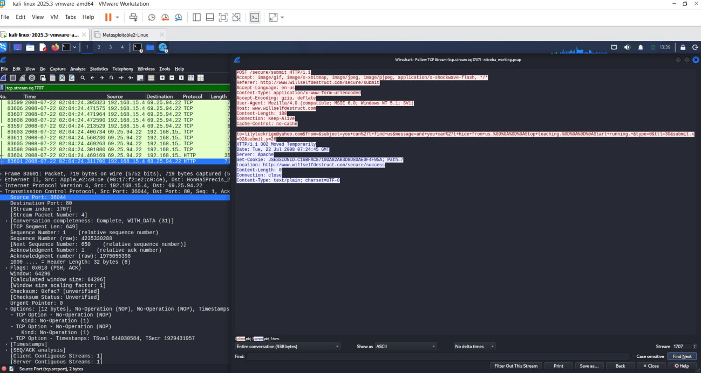

Evidence ID: E03

Appendix D — Cookie and Account Evidence
Include the Wireshark screenshot showing the account/cookie information associated with: 00:17:f2:e2:c0:ce
and:
jcoachj@gmail.com

Evidence ID: E04

Appendix E — Identity Evidence

Include the screenshot for frame 79093 showing the account identifier and the client MAC address.

Field | Evidence
Packet number | 79093
Timestamp | 2008-07-22 02:04:01.359793
MAC address | 00:17:f2:e2:c0:ce
Account evidence | jcoach@gmail.com
Filter used | eth.addr == 00:17:f2:e2:c0:ce && frame contains "jcoach@gmail.com"
Course/Class | Chemistry 109
Student name | Johnny Coach
Email | jcoach@gmail.com
Other identifying information | The packet contains an HTTP POST request to Gmail/mail.google.com, tying the captured traffic to the jcoach@gmail.com account.
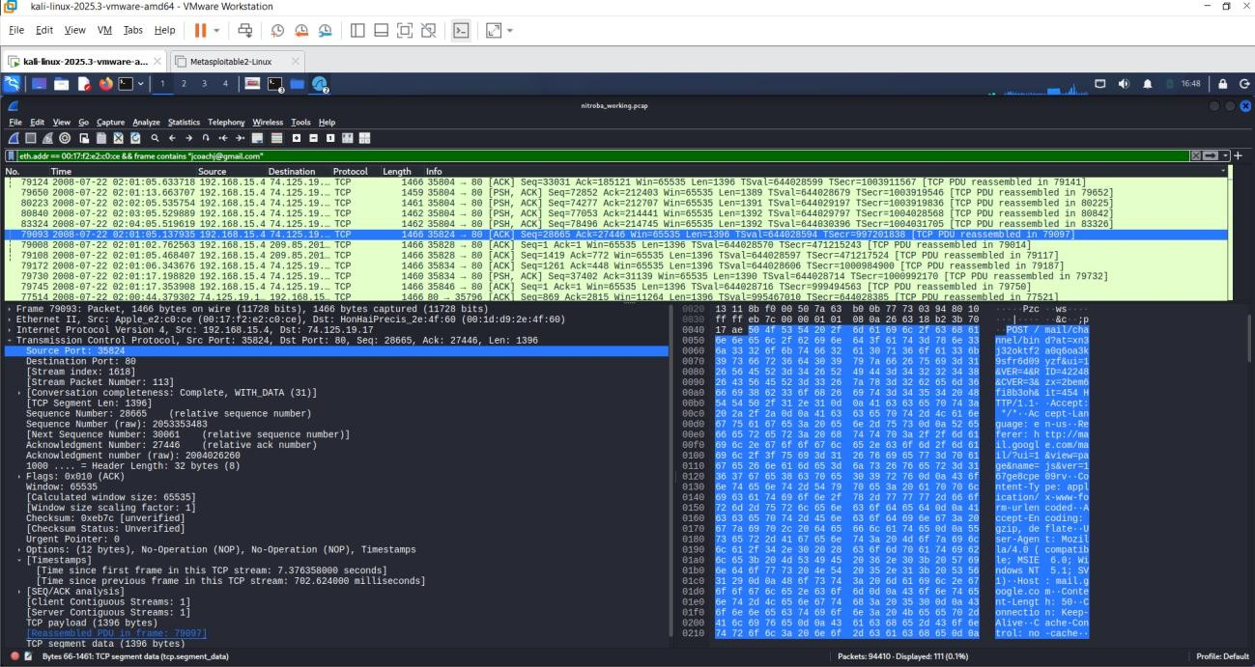

Evidence ID: E05

Appendix F — Chemistry 109 Roster
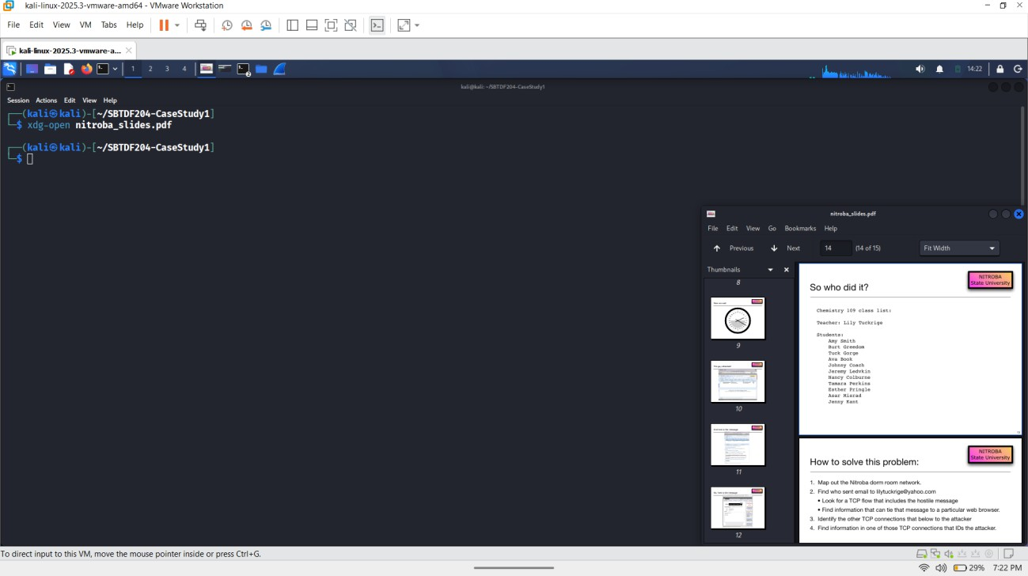

Include the supplied Chemistry 109 roster evidence showing Johnny Coach.

Evidence | Your observation
Wireshark client IP | 192.168.15.4

Wireshark client MAC | 00:17:f2:e2:c0:ce
HTTP  cookie/account | jcoach@gmail.com
Slide 14 roster name | Johnny Coach (based on the account identifier and previously identified roster; verify against Slide 14)
Course | Chemistry 109
Account/name comparison | The account identifier jcoach matches the name Johnny Coach on the Chemistry 109 roster, suggesting that the captured Gmail traffic is associated with that account.

Evidence ID: E06

CHECKING THE IDENTITY CORRELATION

Field | Evidence
Packet number | 79093

Timestamp | 2008-07-22 02:04:01.359793
MAC address | 00:17:f2:e2:c0:ce
Account evidence | jcoach@gmail.com
Filter used | eth.addr == 00:17:f2:e2:c0:ce && frame contains "jcoach@gmail.com"
Course/Class | Chemistry 109
Student name | Johnny Coach
Email | jcoach@gmail.com
Other identifying information | The packet contains an HTTP POST request to Gmail/mail.google.com, tying the captured traffic to the jcoach@gmail.com account.

Investigation of the browser/user-agent
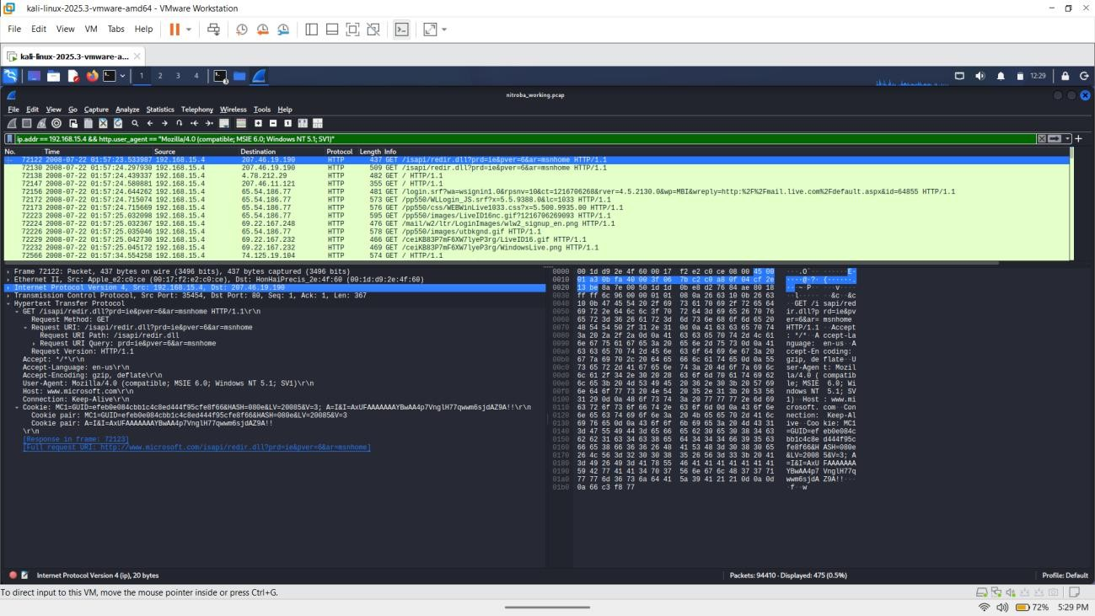

Field | information
Frame | 72122
Time | 2008-07-22 01:57:23.533987
Source IP | 192.168.15.4
Destination IP | 207.46.19.190
Source MAC | 00:17:f2:e2:c0:ce
Destination MAC | 00:1d:d9:2e:4f:60
Protocol | HTTP
Source Port | 35454
Destination Port | 80
Method | GET
Request URI | /isapi/redir.dll?prd=ie&pver=6&ar=msnhome
Host | www.microsoft.com
User-Agent | Mozilla/4.0 (compatible; MSIE 6.0; Windows NT 5.1; SV1)
Cookie | MC1=GUID=efeb0e084cbb1c4c8ed444f95cfe8f66&HASH=080e&LV=20085&V=3
Response frame | 72123
Full request URL | http://www.microsoft.com/isapi/redir.dll?prd=ie&pver=6&ar=msnhome

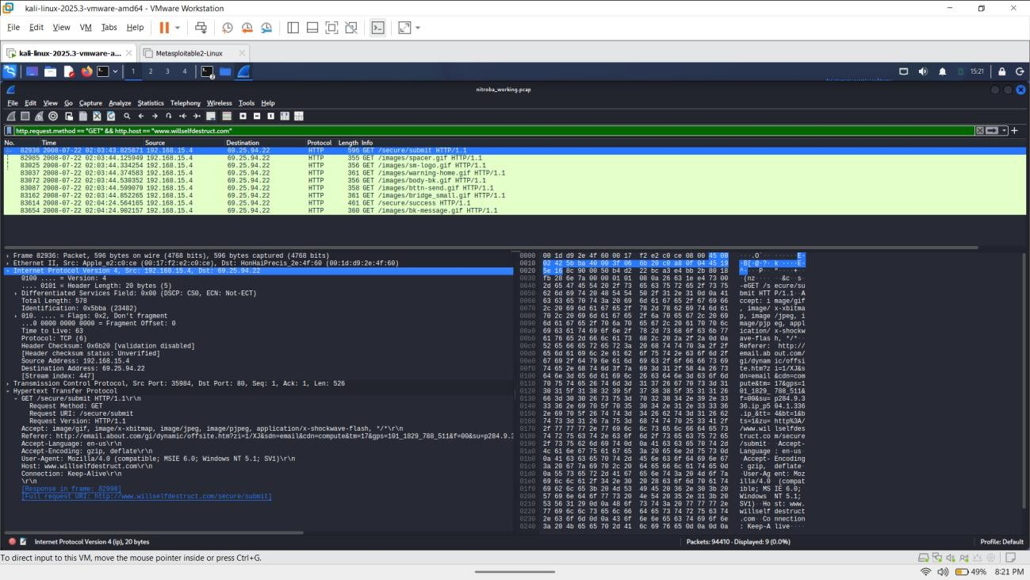

Packet record

Item | Your result
Frame number | 82998
Time | 02:03:43
Source IP | 192.168.15.4
Destination IP | 69.25.94.22
HTTP host | www.willselfdestruct.com\r\n
Request URI | http://www.willselfdestruct.com/secure/submit

Identifying the client MAC address
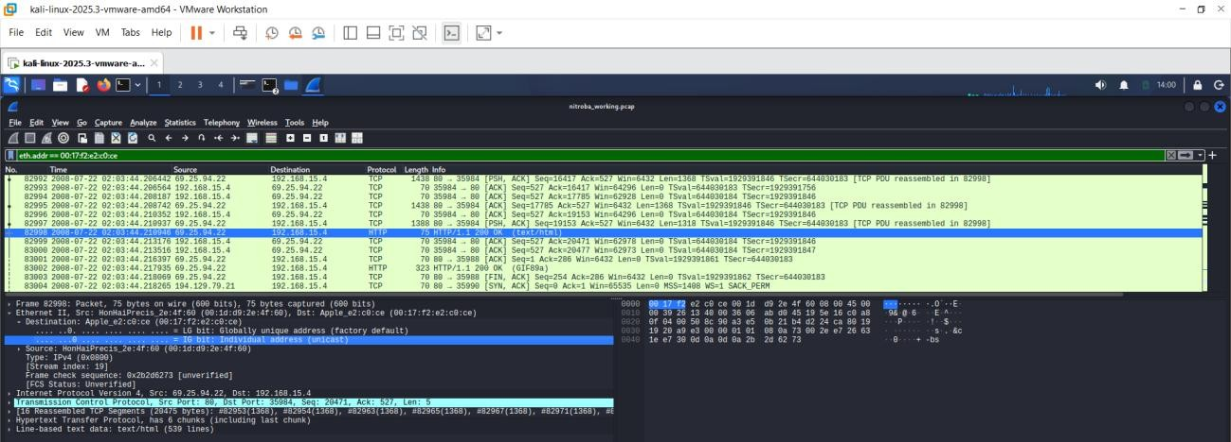

Client IP: | Client MAC: | Service IP:
192.168.15.4 | 00:17:f2:e2:c0:ce | 69.25.94.22

BUILD THE TIMELINE

Time | Frame | Source | Destination | Activity
2008-07-22  02:00:45.360749 | 77711 | 192.168.15.4 | 74.125.19.104 | HTTP POST to /calendar/load associated with Google Calendar
2008-07-22  02:01:05.113795 | 79093 | 192.168.15.4 | 74.125.19.17 | TCP segment carrying HTTP POST data; reassembled HTTP request begins with POST  /mail/cha...
2008-07-22  02:03:43.825871 | 82936 | 192.168.15.4 | 69.25.94.22 | HTTP GET /secure/submit
2008-07-22  02:03:44.210976 | 82998 | 69.25.94.22 | 192.168.15.4 | TCP PSH, ACK carrying HTTP data / reassembled TCP data
2008-07-22  02:04:24.311700 | 83601 | 192.168.15.4 | 69.25.94.22 | HTTP POST to /secure/submit; submitted form data including subject and message
2008-07-22  01:57:23.533987 | 72122 | 192.168.15.4 | 207.46.19.190 | HTTP GET  /isapi/redir.dll?prd=ie&pver=6&ar=msnhome
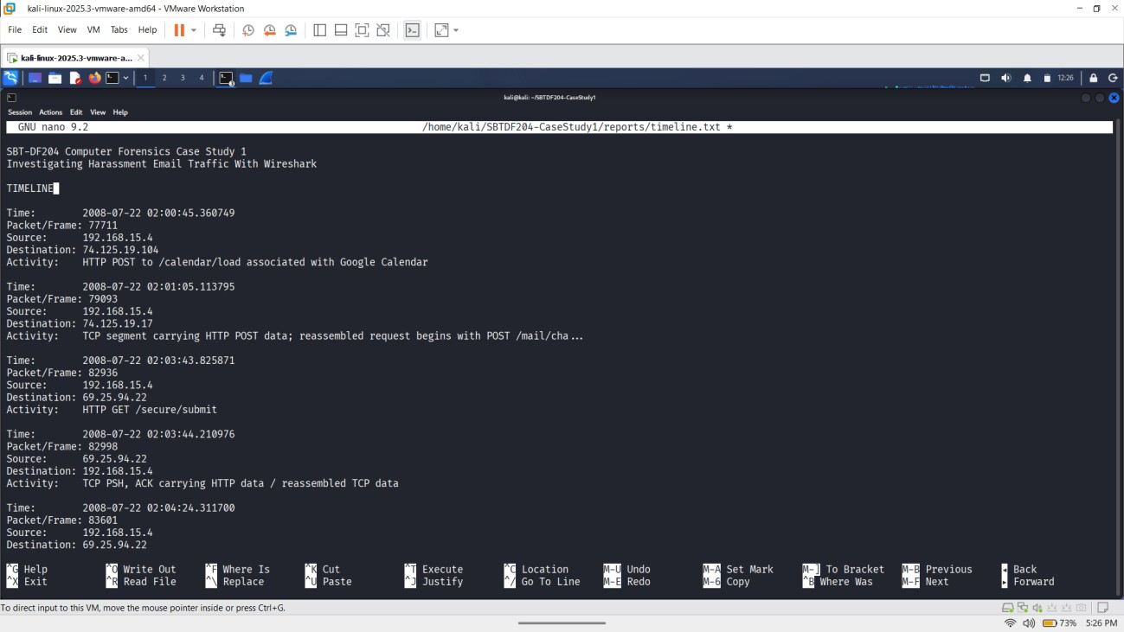
It was saved in ~/SBTDF204-CaseStudy1/reports/timeline.txt

Forensic Investigation Findings
- What file did you acquire, and how did you preserve its integrity?
The acquired file was nitroba.pcap. The documented file size was 817,689 bytes. The document records the file creation/birth time as 2026-10-02 13:19:46.855135481 -0400 and gives the acquisition date as 2026-10-02.

Item | Finding
File | nitroba.pcap
Size | 817,689 bytes
Acquisition date | 2026-10-02
SHA-256 | 3b9cc8a5ec301bd79dd5bbcc7670c9abeddaf508a51181260cd63f8a6871d2e6  nitroba.pcap
Working-  copy method | 2b77a9eaefc1d6af163d1ba793c96dbccacb04e6befdf1a0b01f8c67553ec2fb working/nitroba_working.pcap

Which client system contacted the web service?
The client system was 192.168.15.4, communicating with the relevant web service at 69.25.94.22. The HTTP request identifies www.willselfdestruct.com as the host and /secure/submit as the request URI.

Evidence
Display filter: ip.addr == 192.168.15.4 && ip.addr == 69.25.94.22 Frame: 82936
Time: 2008-07-22 02:03:43.825871
Source: 192.168.15.4
Destination: 69.25.94.22
Frame 82936 is recorded as an HTTP GET to /secure/submit.
The later HTTP POST provides the stronger evidence of the actual submitted message: Display filter: frame.number == 83601

Frame: 83601
Time: 2008-07-22 02:04:24.311700
Source: 192.168.15.4
Destination: 69.25.94.22
The POST was sent to port 80 and used /secure/submit.
Why it matters: These packets establish the network path from the client IP to the web service involved in the reported activity.

What evidence links the client to the harassment message?
The strongest evidence is frame 83601, which contains the HTTP POST request to
/secure/submit.
Display filter: frame.number == 83601 TCP stream: 447
Time: 2008-07-22 02:04:24.311700
Source: 192.168.15.4
Destination: 69.25.94.22
HTTP request: POST /secure/submit HTTP/1.1 Host: www.willselfdestruct.com
The POST contains the following form information:
- Recipient: lilytuckrige@yahoo.com
- Subject: you can't find us
- Message: and you can't hide from us. Stop teaching. Start running. The document also records TCP stream 447 for this HTTP conversation.
Why it matters: This is direct application-layer evidence showing that the client at 192.168.15.4 submitted the reported threatening/harassing message to the web service.
A useful Wireshark filter for reviewing the same evidence is: tcp.stream == 447

or:
frame.number == 83601

Which device made the relevant request?
The client MAC address associated with the traffic is:
00:17:f2:e2:c0:ce
The documented network relationship is:
Client IP: 192.168.15.4
Client MAC: 00:17:f2:e2:c0:ce Service IP: 69.25.94.22
This information is explicitly recorded in the investigation document.
The MAC address is also associated with packet 77711, where the source MAC is 00:17:f2:e2:c0:ce.

Display filter:
eth.addr == 00:17:f2:e2:c0:ce && http.cookie contains "@"
Packet: 77711
Timestamp: 2008-07-22 02:01:45.361069
Why it matters: An IP address identifies a network endpoint at a particular time, but it does not by itself establish which physical device or person was using it. The MAC address provides additional evidence tying the captured traffic to a particular network interface.

Who is associated with the device?
The account evidence identifies:
Account: jcoachj@gmail.com
Packet 77711 contains the account identifier in HTTP traffic. The document records the following:
Display filter:

eth.addr == 00:17:f2:e2:c0:ce && http.cookie contains "@"

Frame: 77711
Time: 2008-07-22 02:01:45.361069
Source MAC: 00:17:f2:e2:c0:ce HTTP method: POST
URI: /calendar/load
Account identifier: jcoachj@gmail.com
The identity-correlation evidence is also recorded in frame 79093:
Display filter:
eth.addr == 00:17:f2:e2:c0:ce && frame contains "jcoachj@gmail.com"

Frame: 79093
Time: 2008-07-22 02:04:01.359793 MAC: 00:17:f2:e2:c0:ce
Account: jcoachj@gmail.com
The scenario evidence associates this account with Johnny Coach and Chemistry 109.
Why it matters: The account evidence provides a scenario-supported link between the captured device traffic and the account jcoachj@gmail.com. It is stronger than simply assuming that the
IP address belongs to a particular student.

- Is that person on the Chemistry 109 roster? Yes, based on the supplied scenario evidence. The identity evidence gives:
Course/Class: Chemistry 109 Student: Johnny Coach
Email: jcoachj@gmail.com

The comparison section states that the captured account jcoachj@gmail.com corresponds to
Johnny Coach on the Chemistry 109 roster. Therefore:
Captured account: jcoachj@gmail.com Roster name: Johnny Coach
Course: Chemistry 109

Display filter:
eth.addr == 00:17:f2:e2:c0:ce && frame contains "jcoachj@gmail.com"
Packet: 79093
Timestamp: 2008-07-22 02:04:01.359793.
Why it matters: The account identifier is supported by the scenario-provided roster information rather than by an unsupported assumption based only on a name or IP address.

Timeline

Time | Frame | Source | Destination | Activity
2008-07-22  02:00:45.360749 | 77711 | 192.168.15.4 | 74.125.19.104 | HTTP POST to /calendar/load associated with Google Calendar
2008-07-22  02:01:05.113795 | 79093 | 192.168.15.4 | 74.125.19.17 | TCP segment carrying HTTP POST data; reassembled HTTP request begins with POST  /mail/cha...
2008-07-22  02:03:43.825871 | 82936 | 192.168.15.4 | 69.25.94.22 | HTTP GET /secure/submit
2008-07-22  02:03:44.210976 | 82998 | 69.25.94.22 | 192.168.15.4 | TCP PSH, ACK carrying HTTP data / reassembled TCP data
2008-07-22  02:04:24.311700 | 83601 | 192.168.15.4 | 69.25.94.22 | HTTP POST to /secure/submit; submitted form data including subject and message
2008-07-22  01:57:23.533987 | 72122 | 192.168.15.4 | 207.46.19.190 | HTTP GET  /isapi/redir.dll?prd=ie&pver=6&ar=msnhome

The most important event in the timeline is frame 83601, because it contains the actual submitted recipient, subject and message.

Attribution Assessment Observed facts
The packet capture shows that:
  - 192.168.15.4 communicated with 69.25.94.22.
  - The destination host was www.willselfdestruct.com.
  - The client used MAC address 00:17:f2:e2:c0:ce.
  - Frame 83601 contained an HTTP POST to /secure/submit.
  - The POST contained the recipient lilytuckrige@yahoo.com.
  - The subject was you can't find us.
  - The message was and you can't hide from us. Stop teaching. Start running.
  - The capture contained the account identifier jcoachj@gmail.com.
  - The supplied scenario information associates this account with Johnny Coach.

  - Johnny Coach is listed in Chemistry 109.

Inferences

The evidence supports the inference that the computer/network interface associated with 192.168.15.4 and 00:17:f2:e2:c0:ce was used to submit the harassment message.
The account evidence also supports an association between the captured traffic and Johnny Coach.

Limitations

The IP address and MAC address do not by themselves prove who was physically using the computer.

The presence of an account identifier in captured traffic also does not necessarily prove that the named account holder personally generated the message. Another person could potentially have used the computer or account.
The shared-network environment is therefore an important limitation when making an attribution.

Confidence
I would describe the network-to-account association as high confidence based on the supplied packet evidence, while the identification of the individual who physically sent the message should be treated with lower confidence because the capture alone cannot establish who was operating the device at that exact time.
My conclusion is therefore that the evidence strongly associates the harassment submission with the identified client, MAC address and account associated with Johnny Coach, but it should not be presented as absolute proof of personal authorship.

Evidence Log

Evidence ID | Packet or Item | Finding | Why it matters | Screenshot / Appendix
E01 | nitroba.pcap / working copy | Evidence file and integrity information recorded | Establishes the evidence examined and its integrity | Appendix A
E02 | Frame 83601 | HTTP POST containing the harassment message | Direct application-layer evidence of the submitted message | Appendix B
E03 | TCP stream 447 | Complete HTTP  conversation associated with the submission | Connects the POST to the underlying  network session | Appendix C

E04 | Frame 77711 | Cookie/account  information associated with the client MAC | Provides  account/session evidence | Appendix D
E05 | Frame 79093 | jcoachj@gmail.com associated with the client MAC | Supports the account-to-device correlation | Appendix E
E06 | Chemistry 109 roster | Johnny Coach listed in Chemistry 109 | Connects the account evidence to the  supplied roster | Appendix F

Final Statement
Based on my examination of the supplied packet capture, I found clear network evidence showing that the client at 192.168.15.4 submitted the reported harassment message to www.willselfdestruct.com. The traffic was associated with MAC address 00:17:f2:e2:c0:ce and the account jcoachj@gmail.com, which the supplied scenario information associates with Johnny Coach, a Chemistry 109 student.
The evidence is strong enough to establish a meaningful connection between the network activity, the account and the roster entry. However, because the capture does not independently establish who was physically using the computer, I would not describe the evidence as absolute proof that Johnny Coach personally authored or sent the message. The conclusion should remain limited to what the packet and scenario evidence actually demonstrate.

